**CIS 4930 – Mobile Networks: Paper Review**

**Leeson Chen, Andy Liu, Ricky Clarke**

**April 10, 2020**

Paper Title: *Characterizing the Propagation of Situational Information in Social Media During COVID-19 Epidemic: A Case Study on Weibo*

Link: <https://ieeexplore.ieee.org/document/9043580>

Authors: Lifang Li, Qingpeng Zhang, Xiao Wang, Jun Zhang, Tao Wang, Tian-Lu Gao, Wei Duan, Kelvin Kam-fai Tsoi, Fei-Yue Wang

Summary:

The paper begins by discussing public usage of social media during the early phases of the COVID-19 outbreak. At the time of writing the virus had not yet become a global pandemic, and was still largely confined to Wuhan and other major cities in China, so the paper’s focus is on Chinese social media Weibo. The paper first seeks to find an adequate definition for the term “situational information” and breaks the definition into categories regarding their usefulness to authorities and the general public. Some categories include updates, criticism, moral support, rumors, volunteerism, etc. After applying this definition, the paper talks about propagation and data collection.

The researchers used keywords such as “New coronavirus” and “unknown pneumonia” in Mandarin Chinese to graph incidences of those terms on Weibo, and found spikes in the data beginning in early January and sharply increasing late January. The paper also discusses whether verified accounts on Weibo, similar to journalists or celebrities on Twitter, used the terms and the impact on the accounts’ followers. Sentiment analysis was also applied to messages. Findings included how the usage of hashtags greatly impacted the messages’ spread, that authorities neglected to pay attention to unverified users (which often supplied vital information), negative information was spread faster, information with more words propagated further, and that accounts with more followers controlled more public perception of the virus.

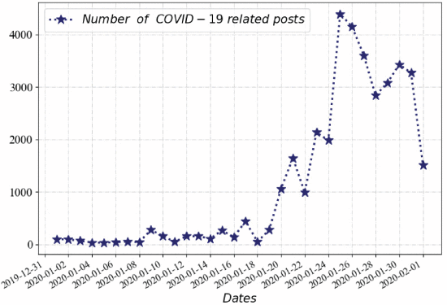

Strengths:

* The paper is good at breaking a massive amount of sentiment-based information into categories using data processing. Analysis of these categories and their usefulness to authorities and the public is also accomplished well.
* The paper also classifies metadata about the Weibo posts such as the poster’s proximity to a large city, their followers and verification / celebrity status. It goes far beyond simple analysis of hashtags.
* Given the very short timeframe, it is good that this paper was published so soon after the outbreak. It can be used to better understand current news regarding COVID-19.

Weaknesses:

* Sentiment analysis was performed using the Linguistic Inquiry and Word Count (LIWC), apparently a commonly used tool for extracting linguistic information from context. However, this software has come under criticism for oversimplicity.
* The paper lacks concrete examples of what type of posts constitute which categories (e.g. what defines a “negative post about volunteering”?). However, this may be due to copyright issues with the author of the post.

Points and suggestions of improvement:

* Because this paper needed to be published so hastily, certain allowances can be made for smaller details. However, much of the grammar and writing in this paper seemed poorly phrased or incorrect. Given that all the authors are from China, this can also be attributed to translation errors. Overall, this is not too big of a deal and should not be seen as a detraction from the paper’s quality or subject material.
* Given the cultural distance between America and China, it is unclear to me how much importance and relevance I should give to an analysis performed entirely on Weibo, which I assume is analogous to Chinese Twitter. This fact may be obvious to the writers, but for a foreign audience unacquainted with China’s “great firewall” of offbrand technology, I would appreciate a quick blurb explaining why trending topics on Weibo are highly relevant as opposed to, for example, the incidences of a keyword on China’s versions of Google / Facebook / Instagram.
* This may be verging deeper into fields of data science and demographics, but a lot of Western / American social media spheres can be further divided into cultural boundaries: for example, there are well-documented sub communities on Twitter that are divided by partisanship, interest in certain bloggers, and so on. To be more specific, there are some groups on social media more prone to subscribing to conspiracy theories, and are protesting the stay-at-home orders in effect by their local governments. If those sorts of subgroups exist in Chinese social media, it would be interesting to see how they are affected and how they churn out different opinions. Currently, the paper treats Weibo users as a mostly homogenous mass, separated only by popularity rather than users’ interests.

Exam Question:

* Q: How do the authors of this paper define their term “situational information”? What are some examples of situational information categories?
* A: The authors define situational information as: “caution and advice, casualties and damage, donations of money, goods, or services, people missing, found, or seen, and information source.”